Computer Language Diagrams

Class Assignment in a Diagram
About the notation of assignment in general, see the article Assignment in a Diagram.

The principle of class assignment is explained in the article Class Assignment. This article demonstrates the expression of it in a diagram.

An assignment is a call to an assignment command, but the expression of an assignment call is given a more basic notation, like this:

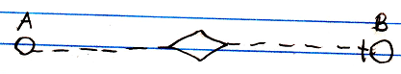

The fact, that the lines are dashed, expresses, that it is a class assignment. The access mark indicates the direction. The target class of symbol A is assigned to symbol B.

If you must have a character symbol for a class assignment, that distinguishes it from the other assignment types, it is a mix of an = and the letter c, which stands for class.

This symbol is the identifier for class assignment. You can also express it as c=.

See also: Assignment in a Diagram, Class Assignment

Author & Copyright: Jan-Joost van Zon Date: July 13, 2008 – July 13, 2008 Location: Oosterhout, The Netherlands Status: Finished

